,

Website: www.friendsofdalesrail.org
Email: enquiries@friendsofdalesrail.org

Newsletter May 2025
Contents
Rod’s Ramblings 1
Event Secretary’s report 2
Train Walk Updates 2
WALKS FROM THE HUDDERSFIELD LINE 2
DALES RAMBLER DAY RANGER TICKETS 3
Holidays 3
YHA weekend 3
In Memoriam - Les Crooke 4
Invitation from Alan and Lynn Saleh 4
Officers, Committee & Assistants 2024-2025 4
Fiona’s Food 4

Rod’s Ramblings
You may not have noticed that the Roman Festival of Floralia and the Celtic Beltane celebrations were held last week to mark the beginning of summer. Hopefully this should ensure a period of warm weather for the next few months. Not that the farmers and water companies are pleased about this as already we are seeing drought conditions across the country. However, for us the bonus of finishing walks with dry boots and completing another successful dry Ride2Stride has been a good start for the spring season, although guess who led an Ride2Stride walk when only one person turned up and he was a member from Skipton!
Our new walks leaflet for June - December has just been printed and will soon be distributed to all the usual places. Many thanks to Cathy for putting it all together and on time despite her busy schedule. Now we can select the walks that look interesting or try some that are in an area you haven't been to before. All signs that we should have a great summer of walks.
Rod Fall, Chairman

Event Secretary’s report
We had a wonderful five days away in Patterdale in March with non-stop sunshine. A big thank you to Rod and David for arranging the programme and to all those who led. A perfect time away. Thank you to Alan Saleh for booking the weekend. We look forward to Dumfries next month.
Ride2stride was hugely successful with visitors from all over England, particularly the south, and from Canada, Barcelona and Lanzarote. The Festival attracts so many who come to discover beautiful Yorkshire and the Settle and Carlisle railway. This year we had exceptionally good weather. A huge thank you to all who supported the Festival and made it possible; to those who worked behind the scenes arranging the talks and booking the venue, the walks, the quiz, preparing the programme for the printers, creating the posters, distributing the leaflets and posters, taking photos and sharing them and of course to everyone who led walks and backed up. What a terrific group of people you are because without you all the Festival could not have happened. This was the tenth Festival and thirteen years since ride2stride was started. Friends of Settle and Carlisle walks group and ourselves have been involved from the start. We thank our sponsors, Castleberg Outdoors in Settle and FoSCL for their financial support. It was great to welcome first timers and to welcome back so many who have been before. Ride2stride has become a regular date in so many people’s diaries. Enjoy a well-earned rest everyone. There are lots of photos on ride2stride Facebook page and I have more to post as people have been sending them in.
A reminder - on Saturday 5 July we are celebrating 45 years of Friends of Dales Rail. There will be four walks on this day and a meal at Shed24H on Hellifield Station. This is for all who have walked or still walk with Friends of Dales Rail. There is another copy of the booking form enclosed with this newsletter. Please make your pie choices...at £4.95 by 2 June.
Diane Taylor

Train Walk Updates

WALKS FROM THE HUDDERSFIELD LINE
As engineering work continues on the Transpennine Route Upgrade project, line closures on various dates are affecting this route throughout the summer. We have two walks planned from this line over the coming months and details are below.
7 June - Greenfield Circular. This strenuous walk is going ahead as planned and to join it from Leeds, please catch the 09:00 bus replacement service from Leeds to Huddersfield rail station. From there, you can catch the train at 09:57 from Huddersfield to Greenfield (Manchester Airport service). The walk will begin from Greenfield following arrival of this train at 10.16. Similar arrangements will apply to the return journey later in the day. Please check website prior to this walk.
20 September - Marsden Circular. This moderate walk is also planned to go ahead, using either the bus replacement service or the ordinary service bus to Marsden. Details of the bus replacement service were not available at the time of writing, or in time for the new train walks leaflet, so please check our website nearer the time for details of the travel arrangements for this walk.

DALES RAMBLER DAY RANGER TICKETS
Since publication of the "Fare's Fair" item in our February 2025 newsletter, the price of these combined bus and rail tickets has now increased to -
Adult: £15.10 - Child: £7.55 - Railcard: £10.10 - Family: £31.20
This article also highlighted the walks during 2025, which may be suitable for using with a Dales Rambler Day Ranger. However, some changes have now been made to our walks programme for the second half of the year.
9 August - the originally planned Malham Tarn to Malham walk has now been withdrawn and the walk on this date will now be a Horton Circular.
27 September - the Grassington circular walk, originally planned for this date, will now take place on 11 October instead.
Full details of all walks can be found in the new train walks leaflet (June to December 2025) and on our website.
Philip Birtwistle

Holidays
Here is advance notice of two holidays booked for 2026.
Park Head Hotel, Bishop Auckland - Friday 20 to Monday 23 March 2026
Metropole Hotel, Llandrindod Wells (mid-Wales) - Sunday 31 May to Saturday 6 June

For those who are still thinking about booking the October weekend at Plas y Brenin, a further copy of the booking form is included with this newsletter.
Alan Saleh

YHA weekend
This year, for your delight and delectation, we are going Goth at WHITBY!
Friday 5 September – Sunday 7 September.
I can’t guarantee the weather but the company will be great and we will have a selection of walks each day (as long as some of you volunteer!) and there is a bar.
The hostel can be reached by public transport and is in a lovely setting near the abbey.
We need to pay the full amount in advance so please send in your application now – I know how easy it is to plan to do it later and then not get a “round tuit”. The application form is at the end of this newsletter.
Penny Smith

In Memoriam - Les Crooke
We have learned of the death of James “Leslie” Crooke on 19 March 2025. Les was involved with Friends of the Dales Rail for many years being a volunteer walk leader. He also made a cake for FDR’s 30th anniversary celebration. (pictured below)
Due to health issues, he was unable to go on any walks in recent years but fondly remembered those he had been on. His daughter kindly sent us this photo of Les proudly wearing his Friends of DalesRail sweatshirt. Glennys Ash and Joan Thompson attended his funeral service.
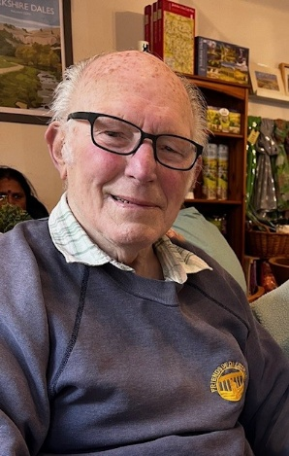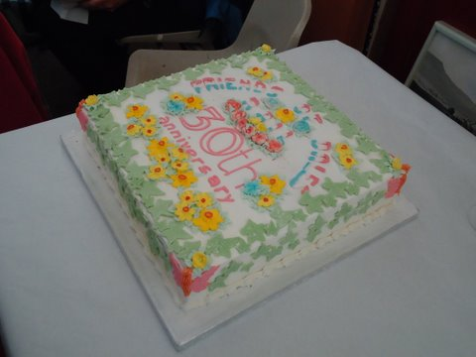

Invitation from Alan and Lynn Saleh
Many of our most long-standing friends are members of FDR and you will know that Lynn and I have been building an eco-house. Well after 7 years it is complete. We would like to invite you to come to our house for a guided tour either singly or in groups. Just ring to arrange your personal tour.
Our address is ########### and the new house is in the garden. (We are very close to the Bradford end of the M606)
Alan & Lynn Saleh

Officers, Committee & Assistants 2024-2025
An updated list of these is attached.

Fiona’s Food
PASTA ALLA NORMA
Here is a nice tasty recipe to fill you up after your walks.
2 large firm aubergines
Extra virgin olive oil
1tbsp dried oregano
Dried red chilli
4 cloves garlic, peeled and finely sliced
Large bunch fresh basil
1tsp herb or white wine vinegar
2 x 400g tins tomatoes
Salt and pepper
150 g salted ricotta, pecorino or Parmesan, grated

Cut aubergines into quarters lengthways, then across the length into finger-sized pieces. Heat oil in a pan and add the aubergines, tossing so that the oil coats them. Sprinkle with oregano and fry until golden on all sides.
Add the dried red chilli. Turn down the heat to medium and add a little oil, garlic and basil stalks. Stir, then add the vinegar and the tins of tomatoes, Simmer for 10-15 minutes, season with salt and pepper. Tear up the basil leaves and add.
Cook spaghetti. Drain it and add a little of the cooking water to the sauce and toss spaghetti and sauce together in the pan. Serve onto plates and sprinkle cheese on top.

